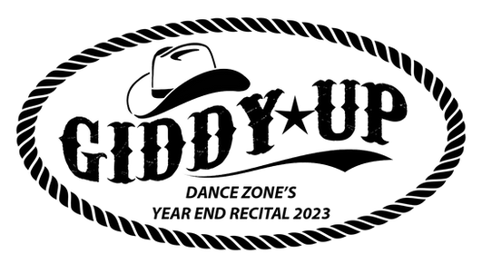
SATURDAY, MAY 27TH @ 1:00PM
HANTS EAST RURAL HIGH, MILFORD

PRE-TROUPE PLUS

Our dancers have been preparing for our Year End Recital and we can’t wait to see them on stage! Please see below for details on arrival times, costuming, etc.

ARRIVAL TIME:
Dancers are to arrive in their costume, with hair done & make-up on. Dancers in the 1st half of the show must arrive at 12:30pm, dancers in only the 2nd half of the show are asked to arrive by 1pm. These dancers can watch the 1st half of the show from the audience and are asked to meet their teacher by the dressing rooms at the start of intermission. If dancers are in multiple classes/routines, please double check the recital line-up to see which routine is first.

COSTUMING & MAKE-UP:
Make-up should be applied so that the dancers do not look washed out on stage with the lighting on them. For make-up, dancers should wear foundation, blush, brown eye shadow, black eyeliner on the top of the lid to extend slightly past the corner of the eye, and red lipstick. Please double check you have all of your costume pieces. Please do not wear other jewelry, nail polish or flashy hair accessories (unless required).

VIDEO & PICTURES:
There is absolutely no video or picture taking of any kind of the performances at any dance recitals or competitions. Please pass this on to any family or friends coming to watch.

RECITAL LINEUP
1 | Boot Scootin' Boogie | Shine & Vibe Junior Troupes
2 | You Can Do It | Primary Acro
3 | Hey Good Lookin' | Kidzdance x2
4 | Wake Me Up Before You Go Go | Int Tap
5 | Bubble Bath | 4-6 Jazz
6 | Oh What A World | Adv Acro
7 | 9 to 5 | Pulse Tap
8 | Joy | Acro Level 2
9 | A Little Party | Vibe Jazz
10 | Hoedown Throwdown | 5-7 Hip Hop
11 | A Friend Like You | Acro Level 1
12 | Yabba Dabba Doo | Shine Tap
13 | Open Hands | Energy Contemporary
14 | We Are A Plot Device | Troupe Production
 | INTERMISSION
15 | Encanto | Junior Production
16 | Wall To Wall | 8-12 Hip Hop
17 | I Hope You Dance | 5-7 Ballet
18 | You Ready? | Power House Hip Hop
19 | Try Everything | Int Jazz
20 | Don’t Worry Be Happy | 4-6 Tap
21 | Ramalama | 8-12 Modern
22 | Toy Solider | Syncro Tap
23 | Diva | 8-12 Jazz
24 | Jailhouse Rock | Minnie Jazz
25 | Waking Up Dreaming | Acro Level 3
26 | Might Delete Later | Energy Jazz
27 | Giddy Up | Pulse, Power House & Syncro

